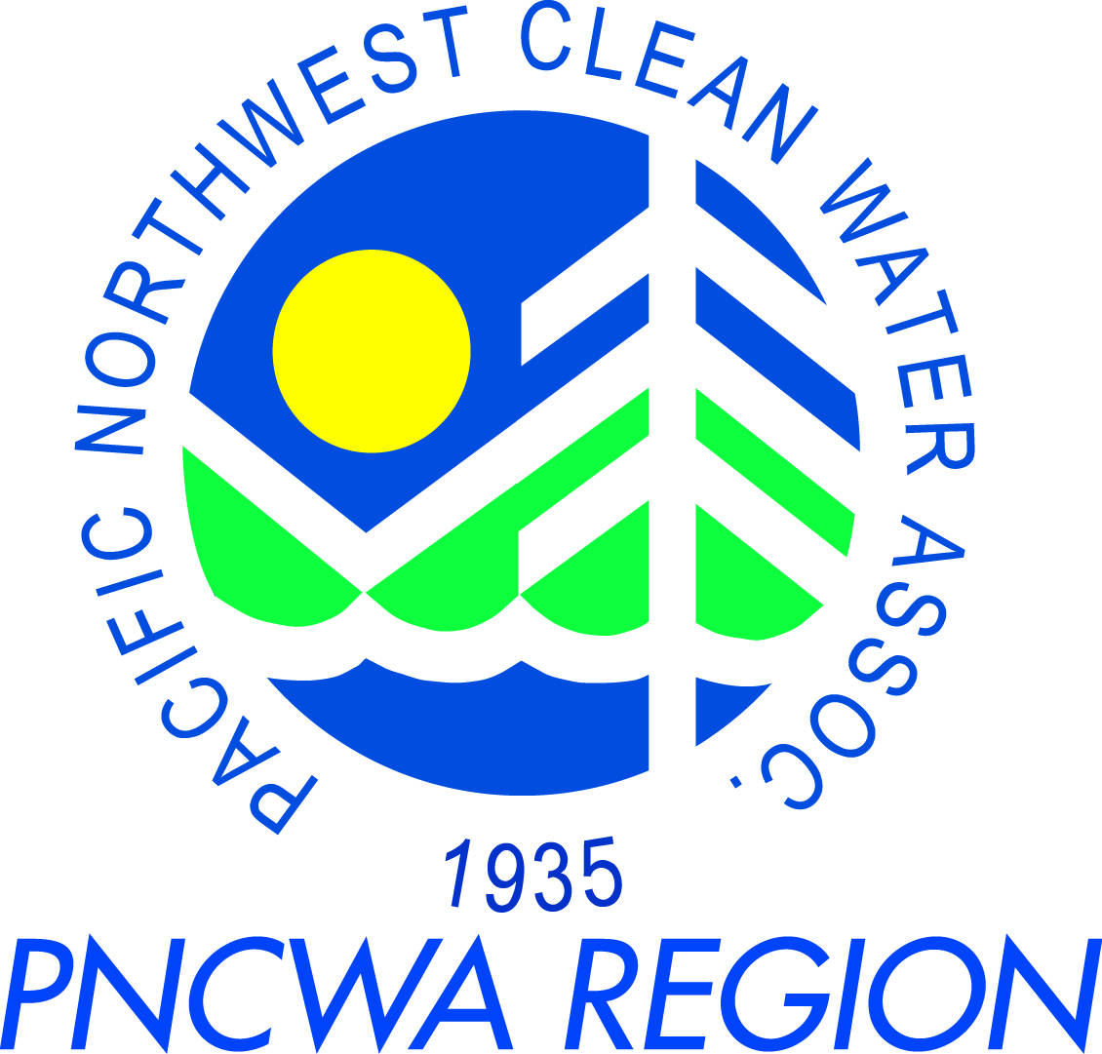
PNCWA – Yakima Valley Section Meeting
Nov 12th, 2014

Meeting Location:
City of Richland
555 Lacy Rd.
Richland, WA 99352

Schedule:
8:30 am – 9:00 am PNCWA Section Business Meeting
- Section News
- Elections
- WEF membership requirements for Section President and Treasurer
9:00 am – 12:00 pm Training (0.3 CEUs)
Session 1 (end 9:45) – Alex Fazzari (JUB Engineers)
Session 2 (end 10:45) – Craig Powers (Penford Food Ingredients)
Break – (15 min)
Session 3 (end 12:00) – Dennis McDonald (Dept. of Ecology)
12:00 pm – 12:30 pm Lunch
Lunch sponsored by JUB Engineers
12:30 pm – 2:00 pm Optional Tour (0.1 CEUs)
Tour of Richland WWTP by City of Richland

Training Topic and Presenter Information:
Session 1:
Presenters: Alex Fazzari (JUB Engineers)
Topic: Comprehensive Sewer Master Plans
Hydraulic Modeling for existing and future capacity. Pipe condition rating. Pipe risk of failure. Overlapping capacity, condition, and risk to create improvement projects.

Session 2:
Presenter: Craig Powers (Penford Food Ingredients)
Topic: Math and Chemistry for Operators

Session 3:
Presenters: Dennis McDonald (Dept. of Ecology)
Topic: Reclaimed Water Rule Adoption Process
Rule Process – documentation and timeline. Update/Overview of the Reclaimed Water Rule and Manual. Update of the Advisory Committee work (that will start this August)

