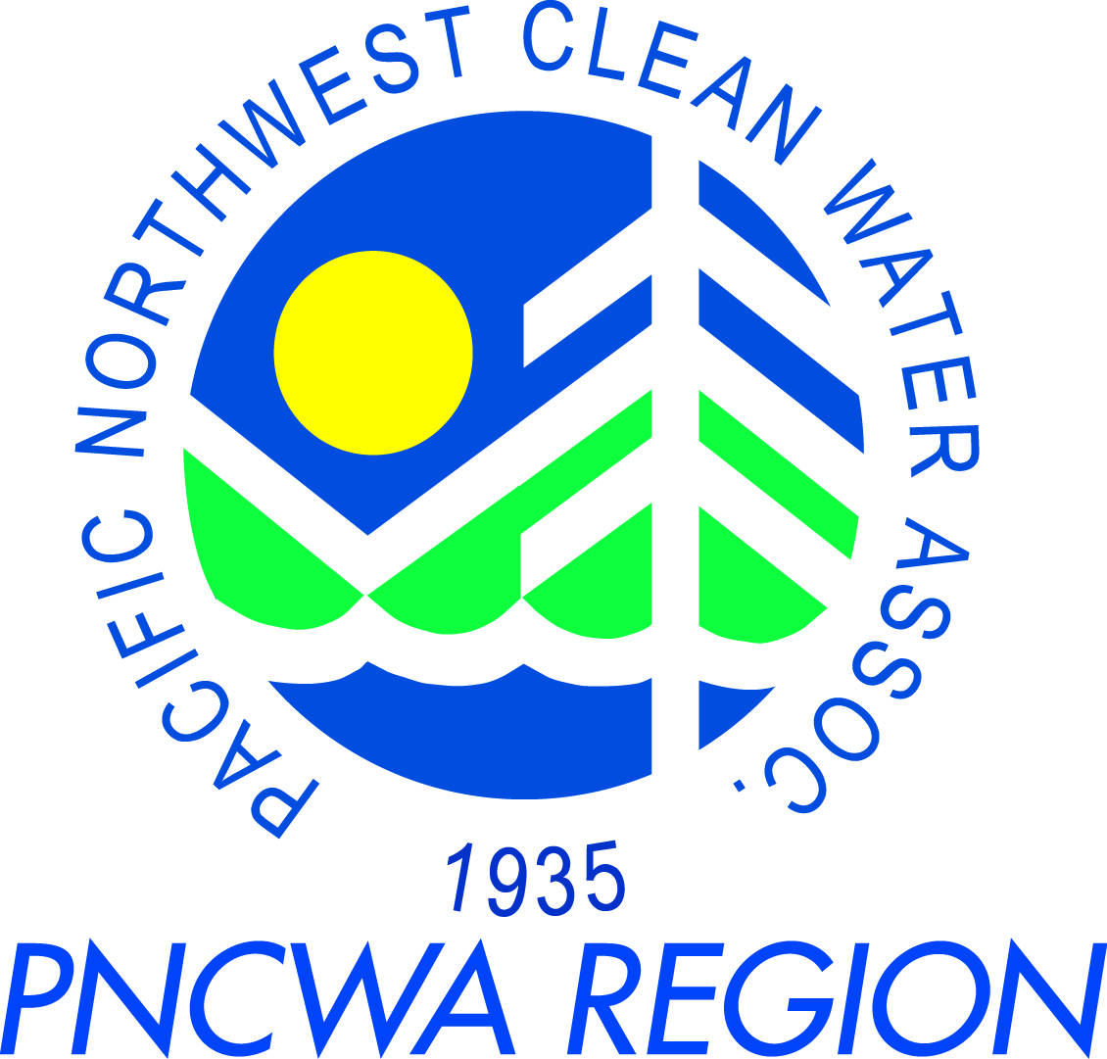
PNCWA – Yakima Valley Section Meeting
April 16th, 2014

Meeting Location: Tour Location:
City of Kennewick City of Kennewick
Wastewater Plant Wastewater Plant
416 N. Kingwood 416 N. Kingwood
Kennewick, WA 99336 Kennewick, WA 99336

Schedule:
9:30 am – 10:00 am Business Meeting
10:00 am – 12:00 pm Training (0.2 CEUs)
Session 1 10:00 am – 11:00 am Chris Espinoza (City of Kennewick)
Session 2 11:00 am – 11:40 pm Zach Wright (JUB)
Session 3 11:40 am – 12:00 pm Brett Converse (JUB)
12:00 pm – 12:30 pm Lunch
12:30 pm – 1:30 pm Kennewick Wastewater Plant Tour (0.1 CEUs, optional)

Training Topics:
Session 1:
Chris Espinoza is the wastewater supervisor and was previously the city’s pretreatment inspector. He will be speaking about the city’s pretreatment program. Including starting up a new program, public awareness and rewriting the Kennewick municipal code for enforcement.

Session 2:
Zachary Wright is a project engineer in the water resources group with J-U-B Engineers in Kennewick. The group specializes in water, wastewater, stormwater planning and design, as well as management issues, economic analyses, and economic impact assessments. He has eight years of experience working on water resource projects for state and local agencies and private sector clients. He holds a degree in Civil Engineering from Washington State University (WSU) (2005).

As part of the City of Kennewick 2014 Sewer Comprehensive Plan Update, their existing sewer collection system model was updated. This update evaluates the condition of the existing system given today’s flows and identifies the impact on the system given future flows. With direction from the City, these impacts are then rated to identify C-I-P projects for the coming biennieum. This talk will discuss the model update, the existing system findings and the briefly identify the future impacts.

Session 3:
Brett Converse has over 23 years of experience in the planning and design of wastewater collection and treatment facilities. He is the design team lead on the City of Kennewick Wastewater Treatment Plant Facilities Plan. He will be discussing some of the research currently being carried out for the Kennewick facility and different upgrade alternatives being considered.

