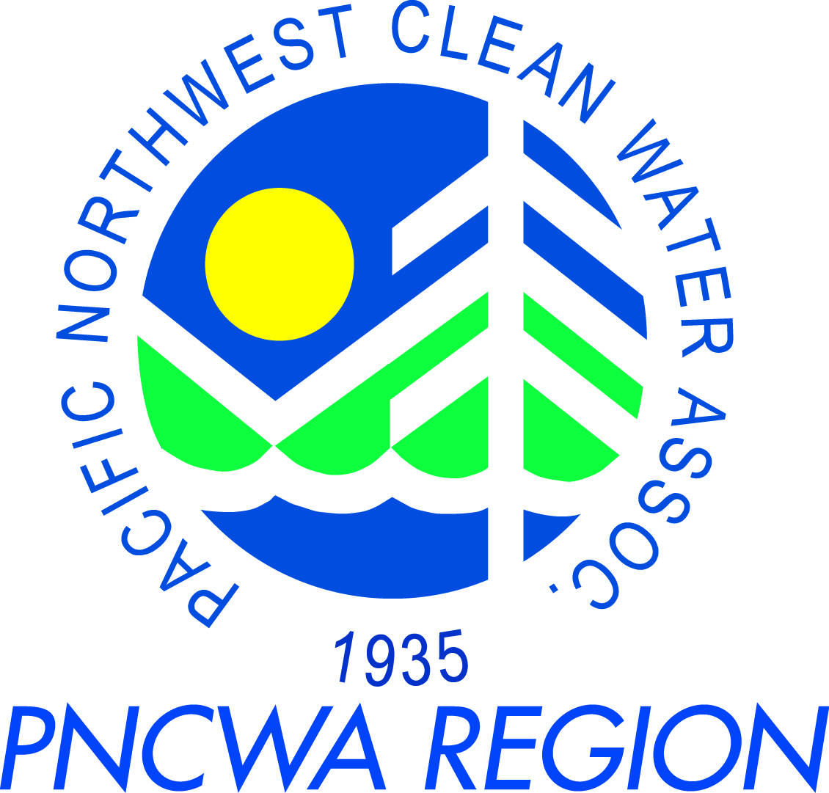
PNCWA – Yakima Valley Section Meeting
June 17th, 2014

Meeting Location:
Southeast Community Center
1211 S. 7th St.
Yakima, WA 98901

Schedule:
8:30 am – 9:00 am Business Meeting
9:00 am – 12:00 pm Training (0.3 CEUs)
Michelle Beason (National Plant Services)
12:00 pm – 12:40 pm Lunch

Training Topic and Presenter Information:

Name: Michelle D. Beason, PE
Current Position: Western Regional Manager
Current Employer: National Plant Services, Inc.

Summary of Experience:
Michelle is a registered professional Civil Engineer in CA, and an expert in Asset Management and Multi Sensor inspections of Water and Wastewater facilities. She currently works for National Plant Services, Inc., which specializes in a full array of specialized environmental maintenance services including: large and small diameter sewer cleaning, CCTV and multi sensor inspections, and lateral/manhole/pipeline rehabilitation and repair.

PRESENTATION SYNOPSIS:
Innovations in Collection System Maintenance:

Efficient collection system management is vital to the prevention of SSO/CSO’s, and to maximize limited resources and budgets facing most cities and municipalities. Many advances in technology are enabling maintenance professionals the tools and information needed to better inspect and manage collection systems. This presentation will start with a discussion on best practices on Asset Management. Asset Management is a continuous process that guides the acquisition, use, maintenance, and disposal of infrastructure assets to optimize level of service, at the lowest life cycle cost.

The discussion will then focus on current advanced inspection technologies available such as SL RAT acoustical testing, multi-sensor robots using laser and sonar and CCTV, and computer maintenance software that centralizes all information from the field to build a complete and effective Asset Management system. Using all of this information, we get a more complete picture of our collection system and can plan cleaning work, and also determine and prioritize repair and rehabilitation work.

We will demonstrate the SL-RAT Rapid Acoustic Assessment tool in the field. Then, based on the results, follow that up with a discussion of how that data can be used to quickly schedule cleaning or TV resources based on need.

Education: B.S., Civil Engineering, Purdue University
License/Registration (if any): PE C55331

