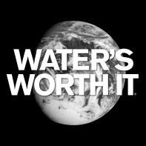
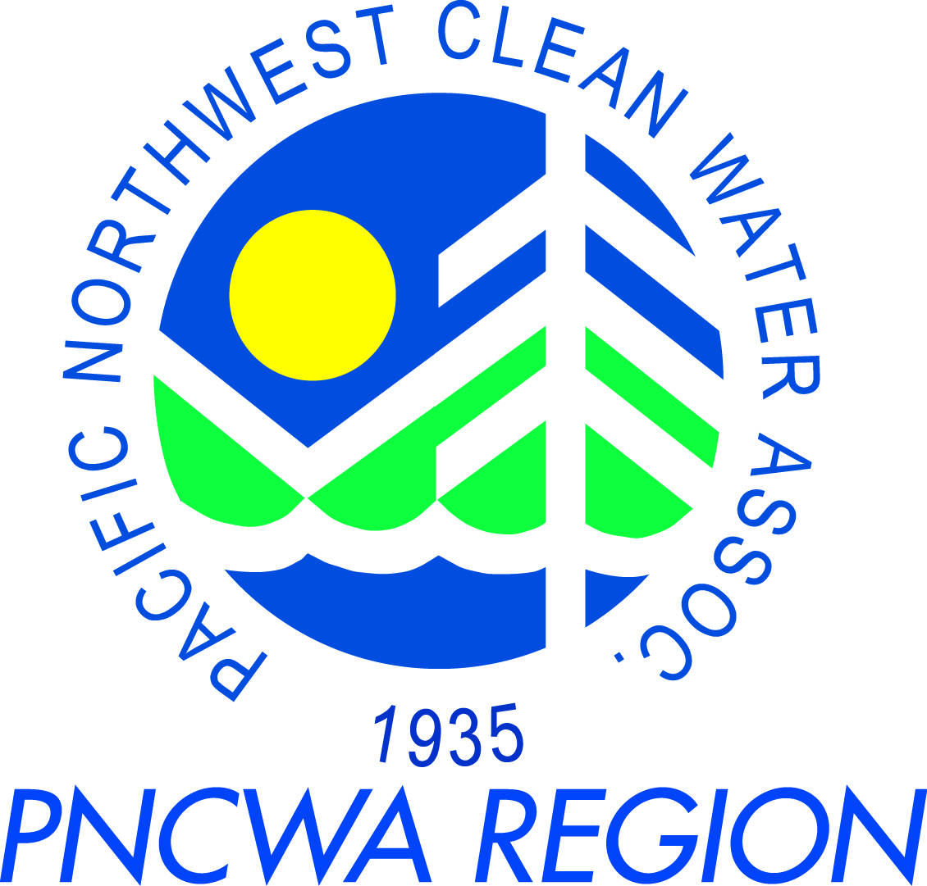
PNCWA – Yakima Valley Section Meeting
August 21st, 2014

Meeting Location:
City of Grandview Library
500 W. Main St.
Grandview, WA 98930

Schedule:
8:30 am – 9:00 am PNCWA Section Business Meeting
- Section News
- Schedule
- WEF membership requirements for Section President and Treasurer
9:00 am – 12:00 pm Training (0.3 CEUs approved)
Session 1 (end 9:45) – Andy Schut (Cascade Analytical)
Session 2 (end 10:45) – Kelly Bladow (Oxarc)
Break – (15 min)
Session 3 (end 12:00) - Justin Bellamy and Ted Pooler (Huibregtse, Louman Associates)
12:00 pm – 12:30 pm Lunch at Grandview Library
Lunch sponsored by Huibregtse, Louman Associates
12:30 pm – 2:00 pm Optional Tour (0.1 CEUs approved)
Tour of Lift Station and Electrical/Pump room by Dave Lorenz (City of Grandview)

Training Topic and Presenter Information:
Session 1:
Presenters: Andy Shut (Cascade Analytical)
Topic: Creating legally defensible data through proper sample collection, preservation, hold time and documentation from a laboratory perspective.
- How sampling procedures can effect data quality and consistency
- Hold times and why they are critical to quality data
- When to preserve and when not to
- The importance of the chain of custody with regard to legal defensibility

Session 2:
Presenter: Kelly Bladow (Safety Compliance Manager at Oxarc)
Topic: Safety with Chlorine and Bleach.

Session 3:
Presenters: Justin Bellamy, PE and Ted Pooler, PE (Huibregtse, Louman Associates)
Topic: City of Grandview Euclid Lift Station and Primary Clarifier Pump Station upgrades.

